ANNUAL REPORT FOR 2020
The 73rd Annual Parish Meeting
January 24, 2021

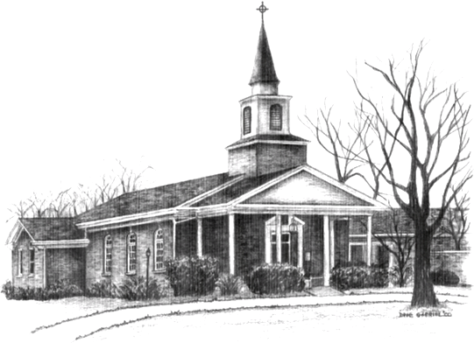

A church with a big heart, shining the light of Christ, joyfully serving others.

The Rev. Stacy A. Walker, Rector
994 N. Fifth Avenue ● St. Charles, IL 60174
www.stcharlesepiscopal.org ● 630.584.2596
RULE OF LIFE at St. Charles Episcopal Church

Our Rule of Life is how we live the Gospel daily.

- Christ is the cornerstone of the church, and prayer is the foundation of our life together.
- We come together in the celebration of the Holy Eucharist on a regular basis.
- We listen to one another with the compassionate heart of Christ and ask questions for clarification.
- We respect one another’s stories by listening and keeping their confidence.
- We strive to practice forgiveness as we have been forgiven through Jesus’ death and resurrection.
- We behave knowing God is in our midst.
- We seek and serve Christ in all persons, loving our neighbor as ourselves.
- We respect the dignity of every human being.
- We actively build worship, education service and giving.

Index

Meeting Agenda………………………………………..….. 5
Minutes of the 2019 Annual Meeting…………………..……. 6
Vestry Biographies…………………………….……..……. .8
Rector’s Report…………………………………………… 11
Deacon’s Report……………………………………………14
Senior Warden’s Report…………………………………… 15
Junior Warden’s Report…………………………………… 16
Light the Way Report……………………………………… 17

S.W.E.E.P.S. COMMITTEE REPORTS

Service, Jill Mosshamer: 22
Free Spaghetti Dinner 22
Hesed House 22
Sandwich Board 23
Jobs Ministry ………………………………. 24
FRVI 24
Salvation Army Angel Tree Program 25
Salvation Army Kettle Program 25

Worship, Regan Jancauskas:……………….25
Lectors ……………………………………... 26
Altar Guild .26
Flower Guild …………………………….…..26
Home Eucharist Ministers ……………….….26
Acolytes ……………………………………..26
Intercessors ……………………………….…26
Music Ministry 26

Education, Candace Moline 28
Adult Formation…………………………..…28
Children and Youth Education 28

Weekly Whispering ……………………....…29
Education for Ministry 30

Evangelism, Diana Brown: ………………...30
Communication 31
Worship in the Community 31
Hunger Relief 31
Blessing of the Animals 31

Pastoral & Congregational Care, Bob Huber:32
Hospitality 32
Daughters of the King 32
Prayers Shawl Ministry 33
Cookie Express 33
Women’s Gathering 33
Men’s Group 33
Columbarium 34

Stewardship, Bob Madura:………………….35
Fundraising 35
Building (Rectory & Church) 35
Finance/Treasurer’s Report 36
Rectors’ Discretionary Funds…….………….40
Year End Statement of Activity- Separate Attachment
Year End Statement of Financial Position- Separate Attachment

SWEEPS Chart - Separate Attachment

St. Charles Episcopal Church
73rd Annual Meeting
Agenda
January 24, 2021, 1:00P.M. on Zoom

· Call to Order
· Opening Prayer/Welcome: The Rev. Stacy A. Walker, Rector
· Appointment of Zoom moderator and explanation of procedures for the meeting and zoom etiquette
· SCEC Rule of Life
· Appointment of Clerk--Kathy Heikkinen
· Approval of Minutes from Annual Meeting January 19, 2020
· Treasurer’s Report for 2020 and Gratitude for Service
· Appointment of Treasurer for three-year term (2021-2023)
· Presentation of 2021 Annual Operating Budget
· Elections of Wardens and Vestry Candidates
· Election of Diocesan Convention Delegates (3) and Alternate Delegates (2): Nominations accepted from the floor
Diocesan Convention: Friday & Saturday November 19-20, 2021, location tba
· Recognition of those ending ministry service: Vestry members, Senior Warden, Treasurer
· Celebration of Adaptive and Continuing Ministries--Featuring: Adult/Youth Formation, Music Ministries, & Free Spaghetti Dinner
· Rector’s Report: Renewal and Regathering
· Our Light the Way Capital Campaign 2021
· Meeting adjourned and closed with prayer

Minutes of the January 2020 Annual Meeting
St. Charles Episcopal Church
72nd Annual Meeting
January 19, 2020
Call to Order: Rev. Stacy Walker called the meeting to order at 11:25.
Announcements: Meeting materials are in the back of the hall; volunteers are needed for Soup Kitchen this week; if no children will be watching a movie downstairs the childcare will be sent home. There was a reminder to sign in.
Opening Prayer: Rev. Stacy led the opening prayer.
Clerk for 2020: Kathy Heikkinen was appointed.
Minutes from the 2019 meeting: Kristen Madden moved to accept; Ed Manning seconded the motion. All voted in favor.
Treasurer: Dallas Heikkinen moved, and Katie Ditch seconded the motion to accept Holly Parks as treasurer. All voted in favor. We will need a new treasurer next year.
2020 vestry: Bob Madura addressed the assembly regarding the composition. Mike Ditch was nominated as Jr. Warden. Candace Moline and Diana Brown are nominated for the 2 open vestry seats. Karen Madura made a motion to accept the names & Regan Jancauskas seconded; upon hearing no discussion, all voted in favor.
Delegates: Rev. Stacy presented the need for delegates for the election of our new bishop. Walk-Abouts (meet and greet) for bishop candidates are the first weekend in June; all are welcome. Only delegates and clergy will be at the cathedral for the election June 20th. The names Kathy Heikkinen, Lela Lowe & Jan Hoffman were brought forward; alternates are Jim Bachman & Kristin Madden. Motion to approve was made by Regan and seconded by Lisel Ulaszek. The following delegates were nominated for the annual Diocesan Convention (11/20-21): Diane Edwards, Jan Hoffman, and Bob Madura; Mike Ditch & Ed Manning were named alternates. Moved by Bob Parks, seconded by Bo Smith. Approved unanimously.
The Rule of Life: Jill Mosshamer led the reading.
Rector’s Report: This is Rev. Stacy’s 4th annual meeting with SCEC. She reflected on her 1st annual meeting, which was held in the sanctuary.
Her focus today is her goals from last year: healthy communications, finances, and the Sunday morning schedule. Change has occurred. Communication will always need to be a focus. Finances are making progress; it took a long time to get where we are, and it will take time to get out of debt as well. Sunday morning is less frantic with only 2 services.
Re: Communication - it will be expanded to include evangelism. We need to spread the Good News in order to fulfill our Christian obligation. We need an Evangelism Committee.
Re: Finances – we need to expand our stewardship. Please pray about finding a new Treasurer. Our debt payment thus far was good; we need a successful Light the Way campaign – be positive & generous.
Re: Healthy Sunday services – we need to be aware of who is not here (babies, toddlers). We do not have a space in the sanctuary set aside for young children or an active nursery; we are not serving the families with young children well enough. Re. Stacy is also looking for us to develop additional activities for fellowship, outside Sunday mornings.
Newcomers: Bill Yeck presented a bag of goodies for Ben Nelson, Oscar & Lila; Suellen McNassar; Kathy Knoble.

Treasurer’s Report: Holly Parks thanked everyone for keeping up on their pledges, especially last summer. This is a generous congregation.
The Finance Committee worked this year on establishing guidelines for the use of the Endowment Fund. New Memorial Funds will automatically go into Endowment; eventually all money currently in the Memorial Fund will be transferred over as well. Every year money will be taken from Endowment to enhance God’s work.
Christmas Appeal was about $39,000. $15,000 in matching funds were deposited in January.

2020 budget: presented by Kristin Madden
There were no questions. The budget was moved by Deacon Steve Lowe, seconded by Janet Craft. Motion was approved unanimously.
Thank you: Dallas was thanked for his service as Sr. Warden. He then thanked others who have served: vestry members, especially those finishing their terms – Bill Yeck & Cynthia Victor. Thanks were also given for new service ministry traveling to serve in Peru this coming summer, led by Hugh Robinson. It appears almost everyone is serving in some way!

Offerings of gratitude:
By Rev. Stacy –for all of us
Janet Craft – Chris Robinson, Deacon Steve, Lela Lowe new to the Healing Ministry; especially Fr. Bill Kruse who has now moved.
Ed Manning – to Bob & Karen Madura who run Hesed House
Victoria Skyles – for Rev. Stacy
Bo – for Bill Yeck
Dallas – for Holly for continuing as Treasurer
Regan – Deacon Steve & Lela; Mark & Lydia
Jill – for this parish family
Holly – for our wonderful choir
Kristin Madden – Bob Parks, Bob Madura, Mike Ditch (Building & Grounds)
Melinda - Bob & Catherine Huber (coffee hours, etc.)
Jack Viverito – for this church
Bob Madura – the foundation on which we can build
Jim Hari – Mark Downey: for his attitude, musical gifts & flexibility; and Lydia who keeps him in line
Faye Viverito – new lectors who have come forward for the 8:30 service
Mike Ditch – senior members of our parish who have steadfast involvement & teach all the rest

Motion to adjourn was made by Tom Miller, seconded by Holly Parks.

Closing prayer was given by Rev. Stacy at 12:22.

==================================================
WARDEN & VESTRY CANDIDATES BIOGRAPHIES

Diana Brown (Jr. Warden)
Kathy Knobel (Treasurer)
Tara Osborne (Worship)
Sandy Peterson (Service)
Lisel Ulaszek (Evangelism)

Bio for Diana Brown
My husband Doug and I have been members of St. Charles Episcopal Church for over thirty years. Before we retired, Doug was a Social Worker in the Forensic Department at Elgin Mental Health Center and I was Director of the St. Charles Public Library. Over the years, I have served on the Altar Guild, as a Lay Eucharistic Minister, as Clerk of the Vestry, and as office support.
As a first year Vestry member in 2020, I have been fortunate to work with a group of dedicated people who have approached the year’s challenges with faith, love, and hope. Decisions for adapting or replacing existing services and ministries have been based on a profound concern for the spiritual, emotional, and physical well-being of the individuals of our church. Even while dealing with the immediate issues of the pandemic, the Vestry always has looked forward.
If accepted as Junior Warden, I hope to use my experience, especially what I have learned during the past year, to support the Rector, Senior Warden, and Vestry as we plan with our congregation how we can renew and replenish our lives, ministries, and fellowship as we work forward together from 2020.
Bio for Kathy Knobel
My husband Pete and I moved here the first time with our two youngest children in 1996 and we attended St. Charles Episcopal Church. When our youngest son, Zach, graduated from St. Charles North in 2003, we decided to move to our lake home in northern Wisconsin. Sadly, Pete died of a heart attack in 2018. I soon realized that I needed to relocate. My friend here in St. Charles found a perfect town house for me and I moved back at the end of 2019. It was wonderful seeing some familiar faces when I returned to SCEC.

I have served in many Episcopal churches in many capacities over the years: Sunday School and adult education teacher, altar guild, lay eucharistic minister, assistant treasurer, treasurer, senior warden, EFM mentor, and finance team chairperson, to name a few.
I look forward to serving as Treasurer here at SCEC, though Holly Parks will be a tough act to follow. Fortunately, she has agreed to help me as I learn the system.

Bio for Tara Dix Osborne
I joined St. Charles Episcopal Church in 2012 with my husband, Dave, and three children, Addie, Evie, and Rowan. Since then I have enjoyed being part of the music ministry team, a youth formation teacher, a Spaghetti Dinner and Sandwich Board volunteer, and a member of the public relations team. I am currently one of the High School Formation teachers, and I am in my fourth year of the Education for Ministry program. I am a first-year student at Bexley Seabury Episcopal Seminary in Chicago, working toward my M.Div. and eventual ordination as a priest in the Episcopal Church. In 2019-2020, my family and I spent a sabbatical year on the Southern coast of Spain. This summer we returned to our life in St. Charles, the town where I grew up and where most of my family lives.

Bio for Sandy Peterson
My connection with St. Charles Episcopal Church began five years ago when I requested a funeral service for my husband, who was the son of an episcopal priest and I felt that he should have this service at the closing of this life. We had not been attending the church, but the priest was there for the funeral home service as well as at the grave site. At the time he invited me to attend any of the services.
Earlier in our married life I had been confirmed in an Episcopal church in Wisconsin.

And so a week later, I started with the Saturday Service, then to the 7:30 a.m. and that is where I found very wonderful people who welcomed me into their church home. It took me a while but soon I moved out of the 7th row where I sat alone, and even went to the coffee hour following the service. All in all I found a loving environment.

After getting to know some of the women, I was asked to join the Altar Guild, Such an honor, and even more chances to learn about the church. I look forward, hopefully, to join the vestry and the challenges and service that face the church. My faith is continually nurtured here, and I hope to provide the service and type of friendly environment for those coming through the door as I did.

Bio for Lisel Ulaszek
My family and I have been members of St. Charles Episcopal since 2008. Our first visit was Christmas Eve of 2007 and from the warm welcome we received, we knew we had found our new church home.

I grew up attending St. Mark’s Episcopal Church in Orchard Park, NY and served as an acolyte and sang in the children’s choir and later, the adult choir.
Since joining our church, I have served as a substitute formation teacher, baked occasionally for the Free Spaghetti Dinner, and oversaw our participation in the Trinity Soup Kitchen for several years. I am currently an active member of the choir and enjoy the opportunity to share my musical gift and fellowship with fellow choir members. Over the next two years, I also have the honor of serving as a Confirm Not Conform sponsor.

I work full time as the Youth & Teen Services Manager at the Sycamore Public Library and enjoy the opportunity to share books and programs with youth and teens. When not working, I enjoy volunteering with my children’s scout troops, traveling, gardening, swimming, hiking, and of course, reading. I look forward to the opportunity to serve our parish as a vestry member for the next two years.

REPORT OF THE RECTOR, STACY A. WALKER

January 24, 2021

Dear Friends,

I am so grateful to be at this time and in this place with you. Last year shortly before the annual meeting I returned from a pilgrimage to the Holy Land. We were just beginning to discuss how we might continue to build on our strengths, and how we could be more hospitable to families with young children in particular. And we were just weeks away from kicking off our Light the Way capital campaign. None of us could have imagined that in less than two months the world would be locked down in the grips of the Covid-19 pandemic. And certainly, none of us had ever imagined what it would look like to have to cancel in-person Sunday services for any reason beyond the occasional severe winter weather event.

I am grateful beyond words to say to all who read this, “We are still here! AND we know that God is still with us!” And not only are we still here, but we have also grown so much in our public witness and communications, in service, and in prayer. This is not a year to ask about the parochial report, or for any sort of census and participation numbers to determine the success or failure of a ministry project. And really, are the numbers the sign of success or failure in ANY year? No. And certainly not in 2020. The stories of how people have continued to care for one another, to remind one another of the hope we have in our faith and trust in Jesus Christ, and the spiritual growth we have experienced in a year when many of our lives shrank down to a very small physical size and space--these are the signs of how we are doing as a church.

Here are some successes I have witnessed as the rector:
- Zoom as a tool for gathering.
- FB Live and YouTube--we have reached new people, including right before Christmas had people reach out asking to be included on our email list.
- Updated our email communication technology to Constant Contact.
- Weekly Whispering revival and renewal
- New Youth Formation classes formed.
- Two new adult education and formation opportunities
- Virtual Choir
- Handbell choir and other musicians continued to make new music virtually and in person.
- Development of a Health and Safety Team of Ushers made in person worship possible for three months August-September.
- Light the Way mini campaign completed in the fall of 2020 to purchase new exterior doors and a new sign on North Fifth Avenue, and we are preparing to roll out full campaign in early 2021.
- AV equipment upgrade preparing us to carry our video ministry throughout the pandemic and beyond.

My challenge and invitation to all of us in 2021 is to shift our focus from just getting by, to investing in the future and legacy of SCEC. I invite each of us to invest financially and as active participants. Yes, 2020 has been a very challenging year. Devastating to many in so many ways. And hope is on the horizon. Vaccines are being distributed. Public health plans are being developed to help our state, country, and world come out of this pandemic time of sickness, death, economic decline, and social isolation. The time now has come for us to dream of our future and start investing in it as each of us is able.

We are still open and operating as a church predominantly online through video ministry, Zoom video conferences, and telephone calls. We need to continue to invest financially in supporting the mission and ministry of SCEC. Give as you are able. That may not be the same as last year. Perhaps this year your income has dropped, and you need to adjust your giving accordingly. Perhaps your income has remained steady or even increased, or your expenses are less than you anticipated. In that case perhaps you can give more. We are about to roll out our capital campaign to renovate Ludtke Hall, our kitchen, and pay off our remaining mortgage debts. Now is also a time to think about how God might be calling you to give over the next three years of the campaign. The Light the Way capital campaign is an act of faith and investment in the future of SCEC and will benefit generations in the years to come.

The year 2021 is also a time to invest in active participation in our church. I know the online experience is not the same as the in-person experience. And yet for many members who have been participating through watching services online or attending various gatherings through Zoom or picking up Home Holy Communion that the presence of God is known when we fellowship with one another in these Covid-19 dictated necessary ways. If you have not tried one of our online or socially distanced gathering opportunities, why not give one a try now? We have several parishioners who have volunteered to serve as “Tech Shepherds” at your request. They will happily help you via phone walk through the process of logging into a Zoom meeting. Or perhaps you would like to schedule your own online SCEC affinity group meeting for coffee chats or a Bible study, etc. Contact the parish office, and we can work with you to help figure that out.

Now is definitely the time to start dreaming and being in conversation with one another about how we will regather in person, when it is God’s will that we do so. In other words, when the Covid-19 pandemic wanes and it is prudent and safe to be in close quarters with one another. There will likely be various stages of regathering. With smaller groups first, for example, or outdoors. And eventually we will be able to safely gather and break bread together both at the altar and over a meal. I want you to think about all the ways we might reconnect as a church. Also, whom will we invite to join us? How will we connect with the neighborhood? How will we serve Christ in our neighbors as we all come out of this stressful and isolating pandemic time?

God willing, in 2021 our Vestry will be making the theme of investing in our future our primary conversation topic. From those conversations there will be events to which you will be invited to participate so that as a church we can all dream together and pray together to discern our bright future that is being held in the hands of God.
In Christ,

Rev. Stacy+

The Rev. Stacy Walker, Rector

REPORT OF THE DEACON, REV. STEVE LOWE

Report of the Deacon to the 73rd Annual Meeting of St Charles Episcopal Church
December 30, 2020
Dear Friends,
I am writing this report just two days shy of the start of the New Year. I really cannot do justice to what we have experienced over the past 10 months in the world, nation, state, city, and our parish and in our lives as followers of Jesus Christ. The Covid-19 pandemic has been a game changer for all of us. Yet here we are – ready to go forth into the New Year with hope that all will be well!
Feeding Ministries
The Rector and I have agreed that my primary emphasis will be our three Feeding Ministries: The Free Spaghetti Dinner (FSD), Hesed House and the Sandwich Board. Great conversations have taken place over the past year regarding these ministries. What do I see as my role? Two primary focuses: #1. Be a good listener to the Ministry heads; #2. An encourager. Listening in terms of ministry strengths, weaknesses, and concerns. The Pandemic has impacted these ministries. For example, FSD changed its serving model to one of pickup of a hot meal instead of a sit-down dinner. The Sandwich Board moved to sack lunches instead of a hot meal. We started out preparing 30 lunches; we are now up to between 70 and 80 lunches.
Lela and I assumed responsibility for The Sandwich Board ministry starting in April 2020. We have worked very closely with the Unitarian Universalist Society of Geneva to continue this ministry through 2021. For the New Year, the Unitarian Universalist Society will assume primary responsibilities with our parish functioning in a secondary support role. This change in roles will allow us to discern our future parish support of The Sandwich Board.
There has been one major structural change regarding The Sandwich Board. The Sandwich Board is now legally separated from Trinity Episcopal Church. Last summer, the IRS granted 501c(3) non-profit status to it. Although it still operates at Trinity, this status change allows greater flexibility in terms of moving forward (for example, submission of funding grants) with the overall ministry.
Healing Prayer Ministry
Lela and I are now part of the Healing Prayer ministry team. We meet monthly to pray, study and plan. When it comes to prayer, I have a six-word question: How Can I Pray for You? Only six words but very profound in the terms of our prayer life.
In addition to my weekly liturgical duties, here are a few activities that I have participated in:
- Seven-week scripture study of the Gospel of Matthew during the 50 days of Easter via Zoom
- Weekly Scripture Check-In with Reverend Stacy
- Leading the service of Compline on Thursday evening. Mark Downey and I alternate weeks as the officiant.
- In the absence of Reverend Stacy, I offered Morning Prayer via our Facebook Live feed on 4 different times.
Some of you may not realize that as a “Vocational Deacon”, I cannot be paid by the Parish for my diaconal ministry. Remember that Bishops, priests, and deacons all have different ministries within the Church. This applies also to our Parish. Reverend Stacy and I have different ministries, but we work together to bring Christ to the world.
SENIOR WARDEN’S REPORT- KRISTIN MADDEN
Let your faith be bigger than your fear - hard words to accept in 2020 my friends! Fear, anxiety, and physical separation made faith and hope difficult to hold on to. It is so easy to see the negative associated with the past year, but as the elected lay leader of the church this year, I used faith to focus on the positive. As I reflect on my time as Senior Warden, I can remember so much good even in the midst of a global pandemic.

When we had to socially isolate to curb the spread of the virus, our Rector and staff researched ways to keep us connected. Kim Cole, our devoted and valuable parish administrator, brought her office home and worked daily to keep us informed. Our rector held prayer services from her living room via social media so we could continue to share the God’s Word together. Then she discovered the World Communion cups which allowed us once again share the Holy Eucharist. Eventually online worship moved back into the church building. I will always remember the video present Rev. Stacy gave us when the church bells rang again after months of silence. It brought tears of joy to my eyes.
And Zoom! We are gradually discovered Zoom!! Zoom allowed us further connection while keeping each other safe but now we could see and hear each other again. We zoomed for coffee hour, adult and children’s formation, Compline, choir, Men’s Group, Women’s Group, Education for Ministry, Vestry meetings, etc. When you think about it, it is quite a long list and we all had numerous opportunities to gather virtually as a church. We are the church, the people of St. Charles Episcopal Church, not the brick walls of the building. Is it the same? No. Is it as enjoyable? No. But it is an opportunity to stay connected when the world demands we stay apart for each other’s sakes. I am so grateful for that. We have an amazing staff that embraced the challenges and found new ways to keep the faith. Thank you to Rev. Stacy, Deacon Steve, Mark Downey, and Kim Cole. You are a blessing to us all! Thank you to all the lay leaders of the various groups and ministries who kept the faith this year and kept us connected. It is a long list of faithful men and women. Thank you to my fellow vestry members for the amazing teamwork we demonstrated this year.

It was a difficult year, and we should not dismiss just how challenging it was. Anxiety was justified. The challenge was to let faith help us rise above it with God’s help. I firmly believe as a collective church our faith allowed us to rise above it.

I leave you in excellent and capable hands! Bill Yeck and Diana Brown will lead new vestries whose faith will be bigger than their fears. To quote a line from my favorite musical: just you wait!

Love and peace my friends!

Kristin Madden

JUNIOR WARDEN’S REPORT- BILL YECK
I look back at this year and see our parish dealing with so many new issues and questions. I have seen the music director Mark learning and then training the choir on how to virtually sing together, spending the extra time to make this happen. I have seen Kim our Parish Admin spend the extra time to learn and deal with new software and technology while trying to do extra jobs parishioners have done in the past. I have seen the Vestry spending extra time and meetings to communicate, to plan, to execute new ways of communication and health protection. Deacon Steve learning and using new technology running compline and using Facebook to send out daily prays. Rev. Stacy streaming services from her home and the sanctuary on her own phone to keep us together remotely and communicating, communicating, communicating.
The many meetings attended on Zoom with the parish and the diocese with the convention and Bishop election. The entire parish using their time and talents to continue to spread the gospel and becoming so flexible to the changes that occurred daily this year. Everyone learning and using new technology. Teaching people how to use technology. Formation classes and bible studies online, men’s and women’s groups meeting virtually. The calls parishioners do out of their hearts to Listen to those who are lonely and afraid. A giving beyond pledges, understanding others are in need and struggling. A thought of “I will lift you up as you have lifted me up”. The drive through meals for Free Spaghetti Dinner and the sandwiches put together by individual families for Hesed House. Lastly the drive through and delivered communion.
The parish showed that we are the body of Christ and that through him all challenges can be met and each of us has our part and passion. We are individuals but together we shine the light of Christ. Wherever we are or whenever we are: God is with us! This will continue to be the case as we move into the new year as changes will continue. We will meet the challenges as we strive to reflect God’s light in the church and our community.

LIGHT THE WAY 2020 ANNUAL REPORT- ERIK BALISI & BILL YECK
In 2019, St. Charles Episcopal Church (SCEC) began planning for a capital campaign to address important renovation and financial issues facing the parish. Through the Diocese of Chicago, we continued our engagement with the Episcopal Church Foundation (ECF), begun in 2018, to guide us through a three-phase process: 1) discernment, 2) feasibility study, and 3) invitation to the parish to make financial pledges.
Having completed phases 1 and 2 in 2019, plans were in place at the beginning of 2020 to proceed to the third phase (inviting pledges) with a campaign goal of $275,000. This goal was determined by the Feasibility Study process.
When the coronavirus pandemic hit, the Light the Way leadership team paused the campaign and assessed how to move forward with the projects that parishioners had identified as priorities in phase 1, namely:
- Retire the debt
- Renovate Ludtke Hall
- Renovate the kitchen
- Replace and repair doors
- Install an electronic sign along Route 25

The Light the Way leadership team did not want to defer our dreams for improving our church building and strengthening our ministry. So, in consultation with ECF, parish leadership agreed to have a “mini-campaign” with two objectives. The first was to demonstrate to ourselves and our community that SCEC remains forward-looking, anticipating the day when all SCEC ministries will be able meet again in person. The second objective was to raise funds for some of the projects identified for the capital campaign. The mini campaign was to be directed at parishioners believed to have the ability to make gifts in 2020 so that the projects could commence in 2020. The Light the Way leadership team set a goal for the mini campaign of $40,000.
We are pleased to report that $37,691 has been contributed by12 families. We are grateful for the prayerful demonstration of generosity.
Because of these gifts we were able to install new doors and a new electronic sign along Route 25, and contribute to the Diocesan Endowment Fund, as described below.

Doors
We replaced old and worn-out exterior doors and added windows to office doors. In the spring when the weather warms up we will paint the new doors (currently they have gray primer on them) and repair the narthex doors (the large main doors to the sanctuary) so that they close smoothly.
- The double doors that lead from the courtyard to the library and office area were replaced with metal doors with windows to allow for improved light and visibility.
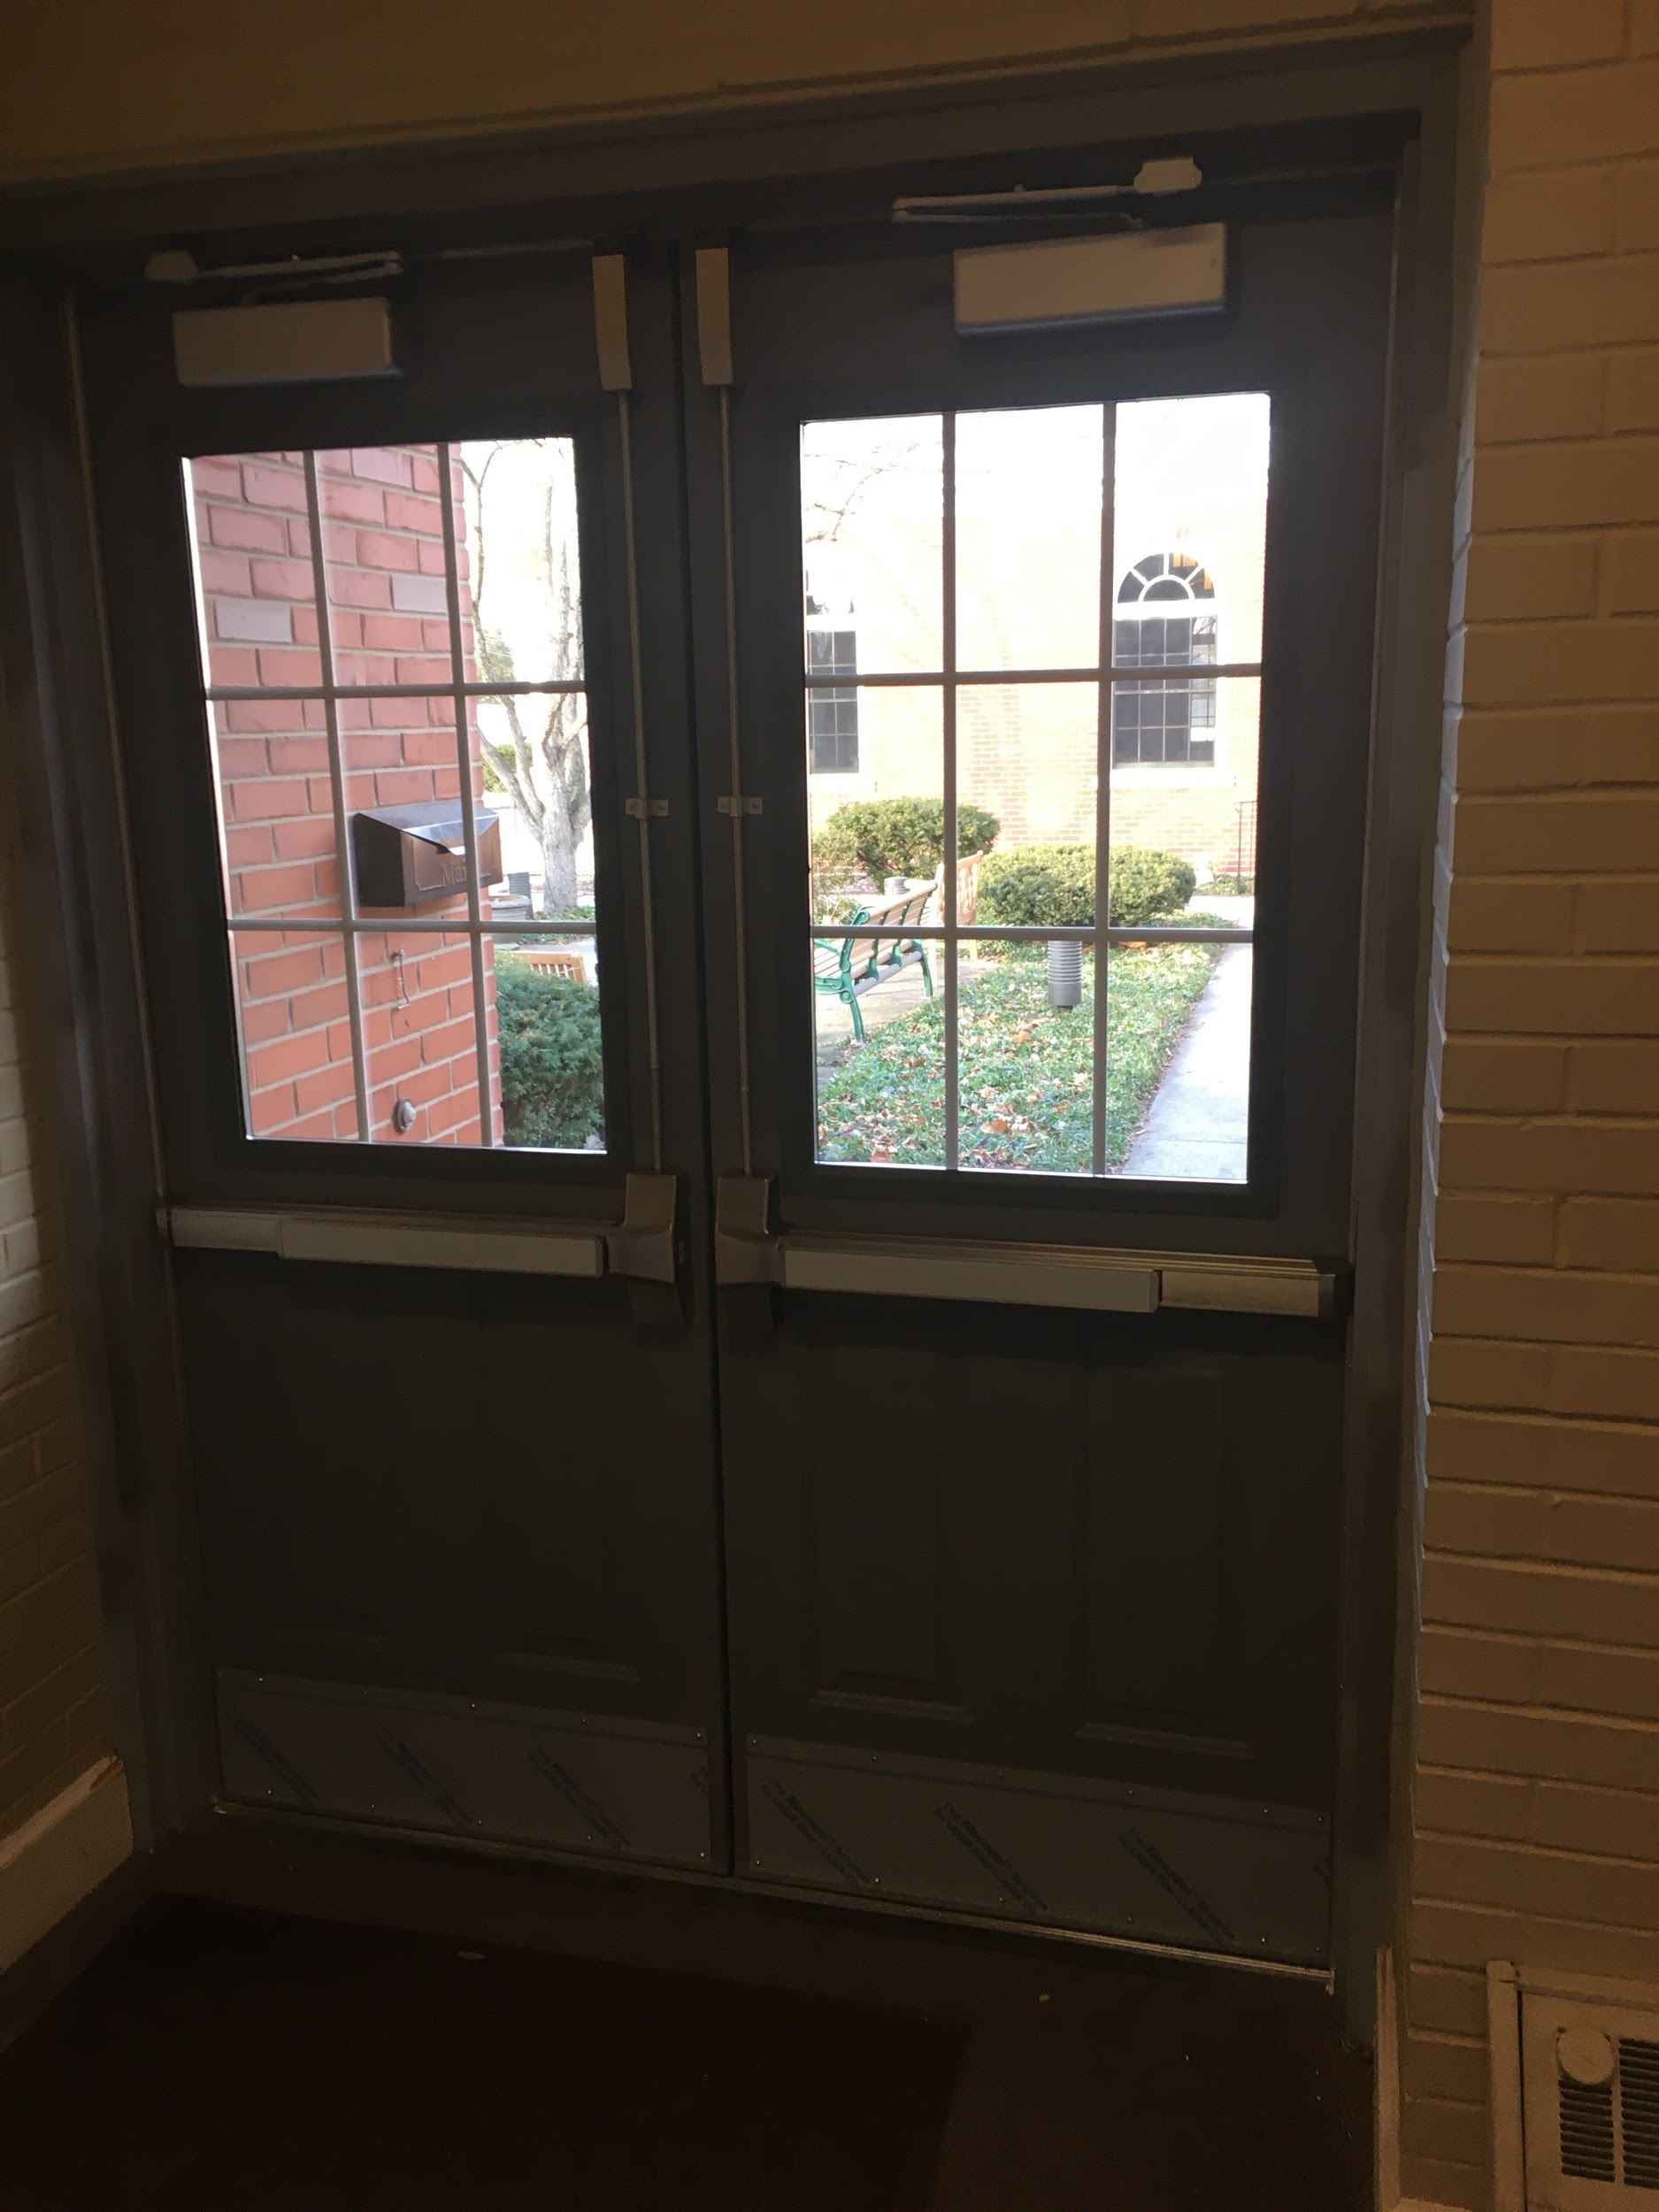

- The door in the east stairwell (the stairs that go from the Ludtke Hall and the kitchen to the lower level) has been replaced with a metal door. The design is the same as the old door but unlike the old door, which did not close properly and was often left ajar, this one actually closes and latches reliably for improved security.
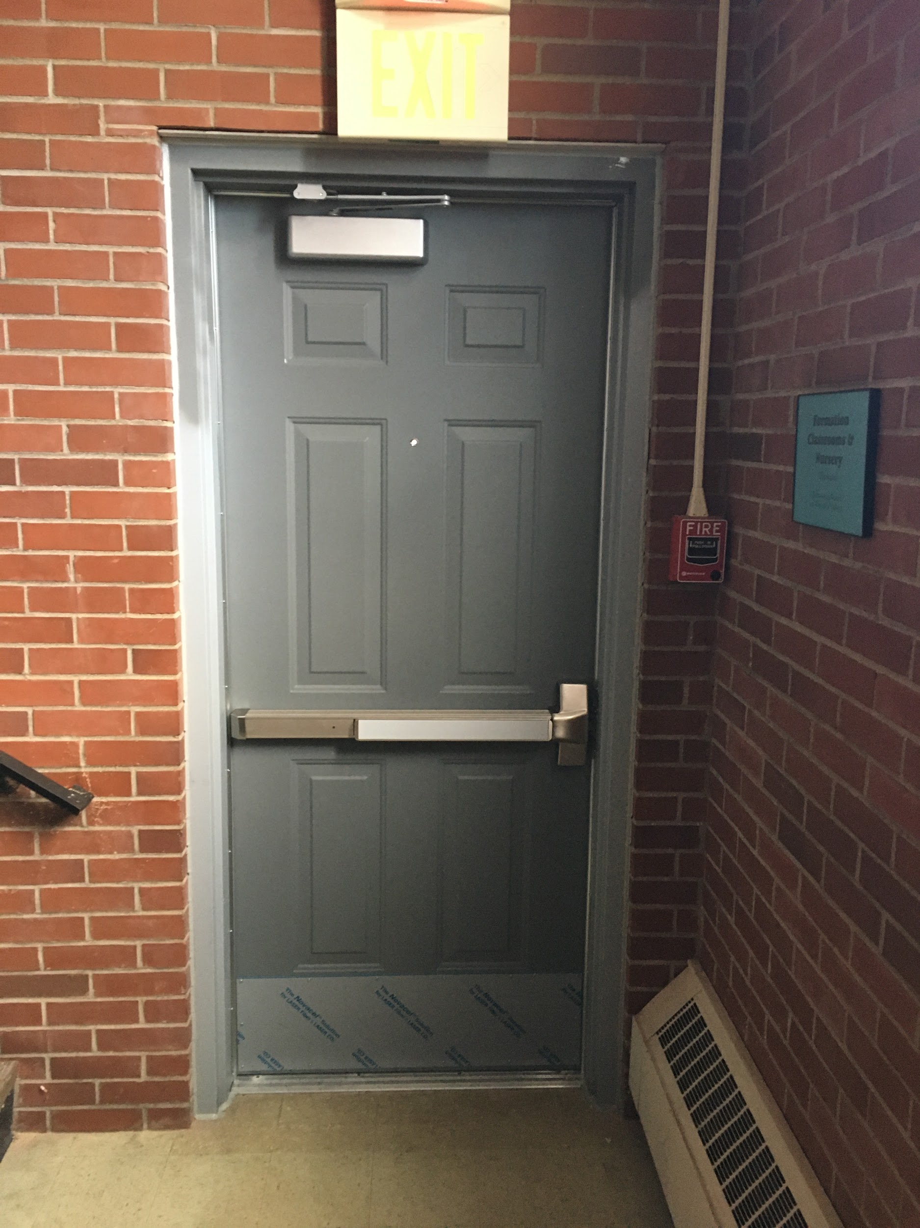

- Windows were added to the four office doors: Rector’s office, Director of Music’s office, Parish Administrator’s office, and the copier room. This safety improvement gets us into compliance with Keeping God’s People Safe guidelines, which require windows in interior doors. It also improves the light in the hallway leading to the Rector’s office.
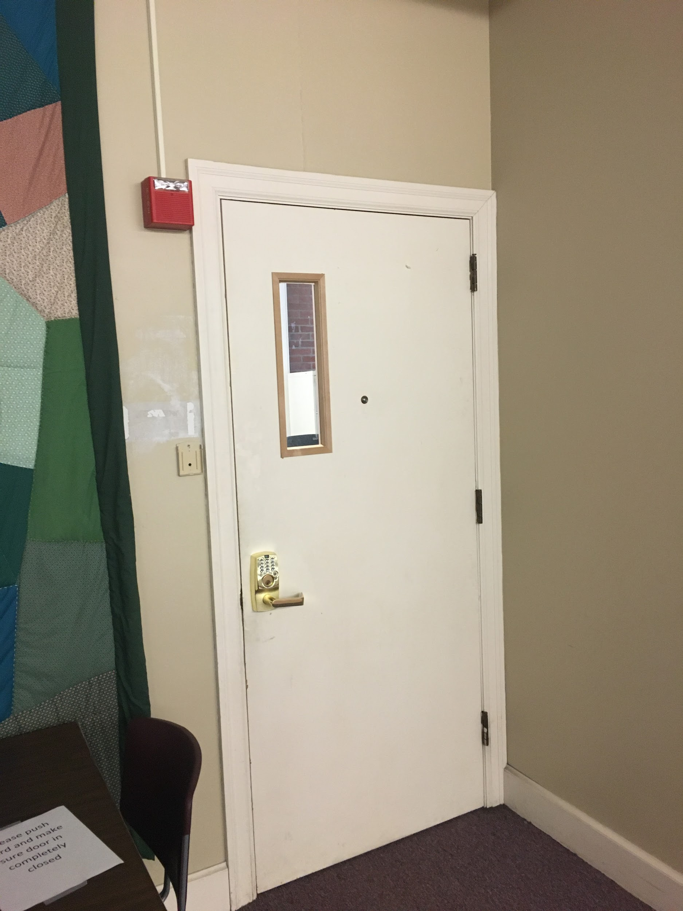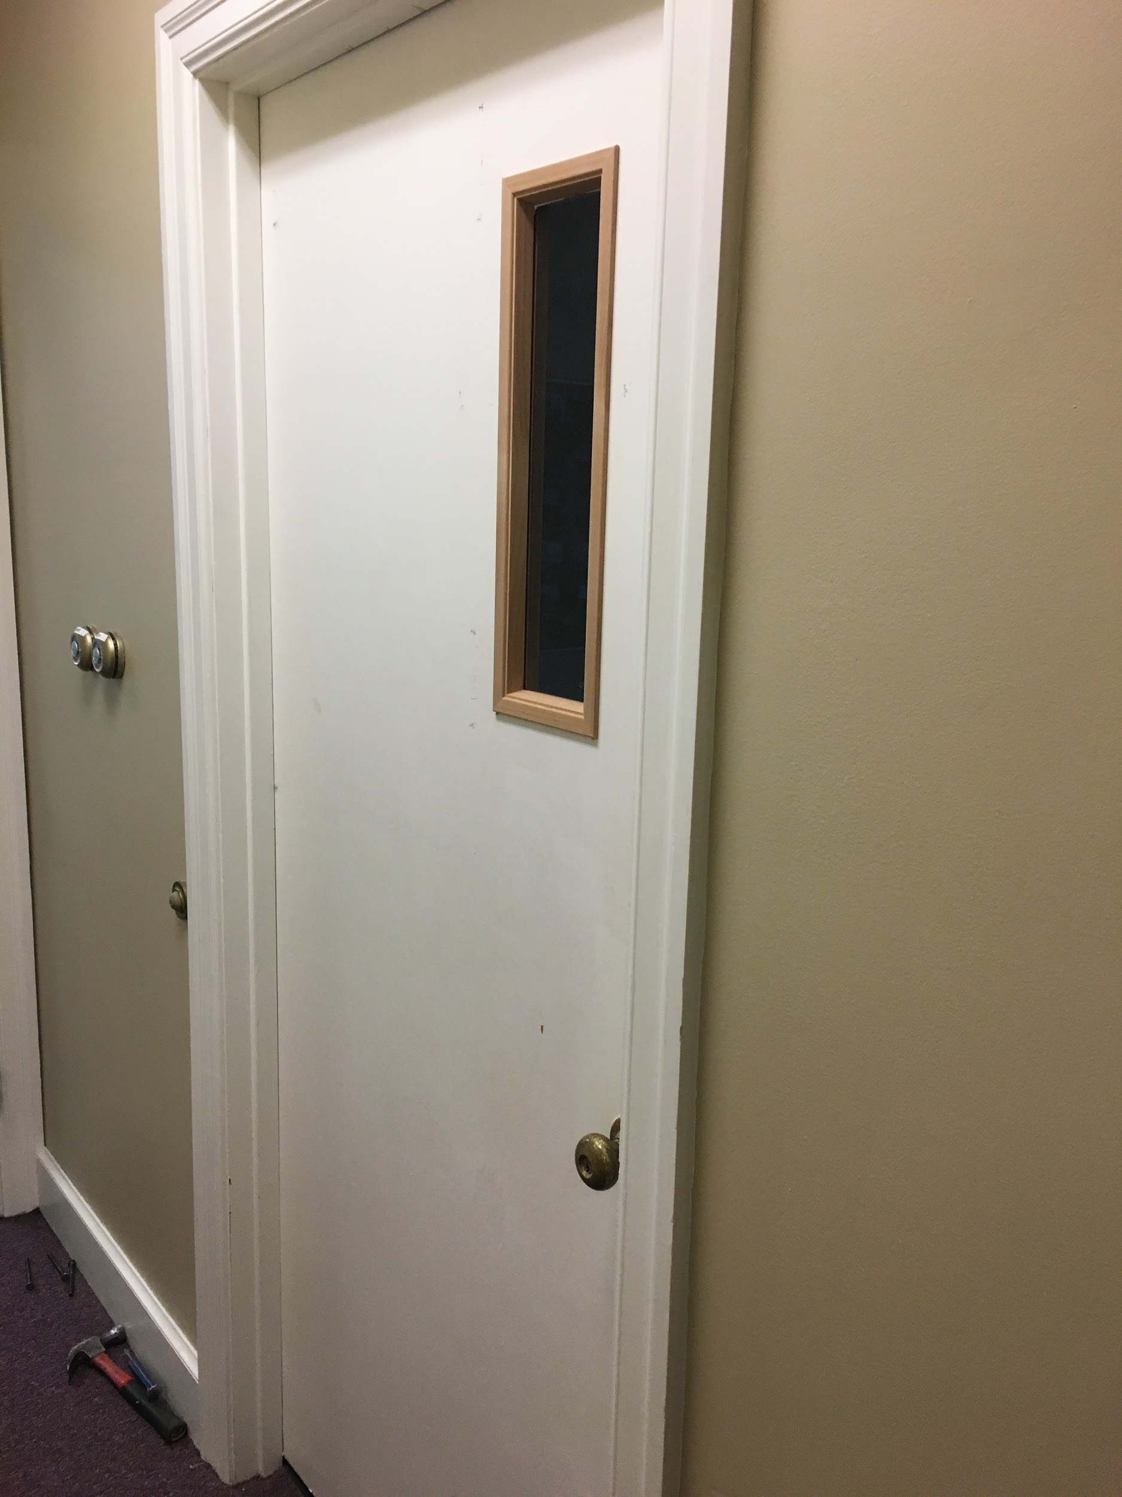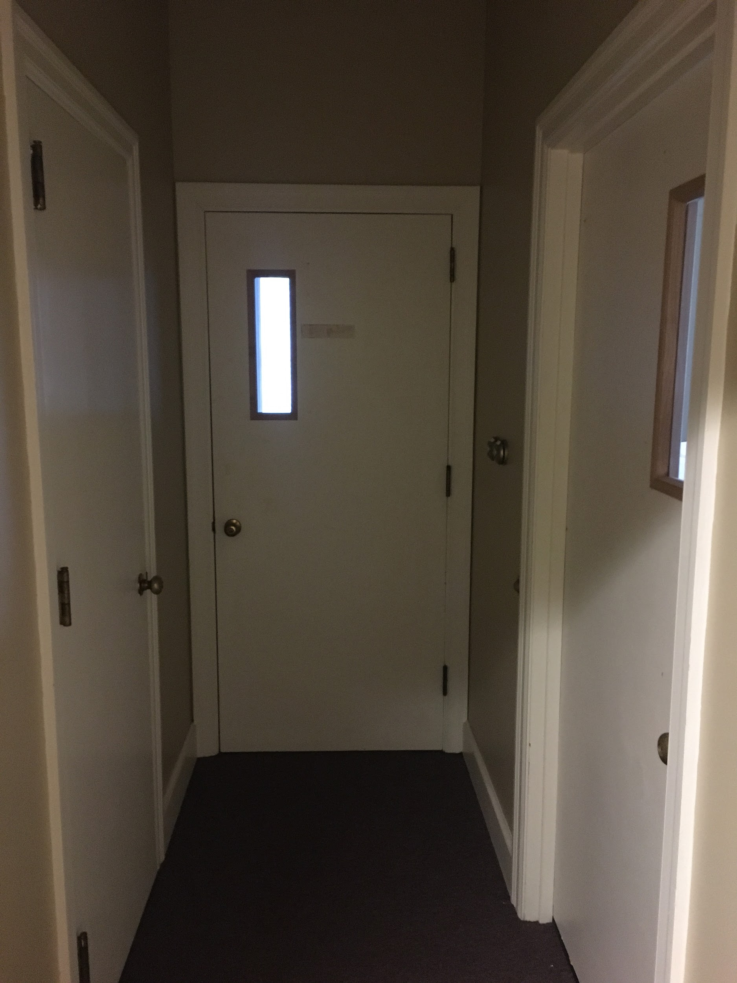

Electronic Sign
In 2020, we began work on installing a new electronic sign. The necessary electrical work is done, and we anticipate that the new sign will be installed in early 2021. The new sign will sit within the existing brick columns and will have landscaping around it, as required by city code.
The new sign will enable us to better connect with our community by providing timely messages in a more eye-catching format that passersby are more likely to notice, day or night. It will also be easier to update since updates can via computer.

Here is a rendering of the sign:

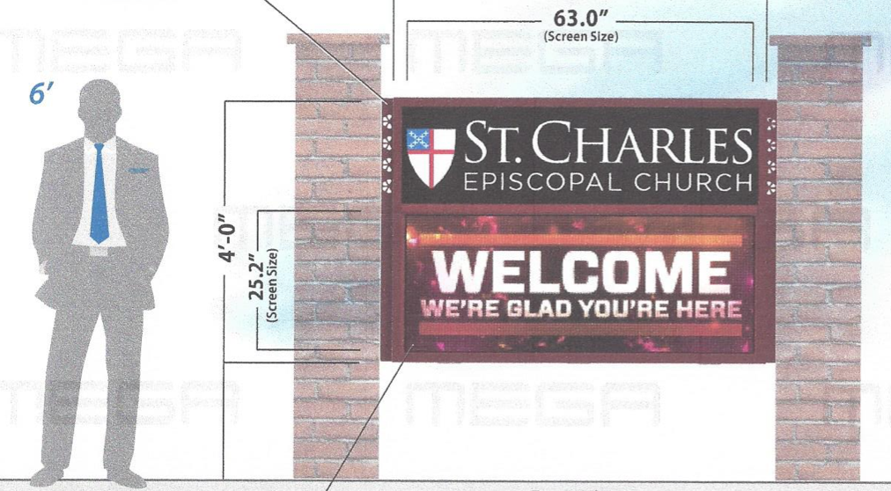

Offering to the Diocesan Endowment Fund
The Light the Way leadership team received invaluable guidance and support throughout the year from Jim Buggy, an Episcopal Church Foundation consultant and expert in capital campaigns. Jim’s services were provided to SCEC at no charge through the Diocese of Chicago’s Diocesan Endowment Fund. In gratitude for the support we received, and in support of ongoing diocesan ministries, 10% of funds raised will be donated back to the Diocese.
Looking Forward
We are planning to begin the parish-wide the Light the Way campaign in the first quarter of 2021 to address the remaining projects.
Thank you for your support of and devotion to St. Charles Episcopal Church. If you have any questions regarding the mini-campaign or the Light the Way campaign, please do not hesitate to contact a member of the leadership team:
- Rev. Stacy Walker
- Bill Yeck
- Erik Balisi
- Kristin Madden
- Dallas Heikkinen

Respectfully submitted,
Erik Balisi and Bill Yeck, Co-Chair

S.W.E.E.P.S. 2020 Ministry Reports
SERVICE REPORTS – JILL MOSSHAMER
Due to the pandemic 2020 quickly became a challenging year to create innovative ways to meet the needs of those less fortunate, and still provide safety for our many volunteers. I have been humbled and honored to work with this compassionate, committed group of leaders who have demonstrated just how important and basic helping the hungry and the poor is to our Christian Faith. It is what Christ asks us to do. Thank you and may God bless you.
Free Spaghetti Dinner
The 11th year of Free Spaghetti Dinner began by serving spaghetti and meatballs, garlic bread, salad, and a dessert to approximately 140 guests the last Sunday of each month. The meal was prepared and served at SCEC by SCEC parishioner volunteers, and some external volunteer friends. Dallas Heikkinen coordinated the cooking, and Kathy Hari coordinated volunteers who served guests. Felicia Deli and Meat Market of Elk Grove donated the meat, and entertainment was provided by Jeremy Glaser (keyboard) and Tom Kirkland (vocals). With the outbreak of Covid-19 it was necessary for Dallas, Kathy Hari, and their team to find a creative solution to continue providing the FSD, so they began serving spaghetti dinners in special containers for drive through curbside delivery, providing up to 171 meals, with some going to Lazarus House. Due to a spike in the virus in November FSD had to be cancelled. During a December spike the FSD team attempted a take-and-make curbside drive through by providing kits that contained spaghetti noodles, a container of sauce and dessert to feed four people. There were 20 cars that came through and only 29 kits were given. The FSD team is hopeful that in January they can return to cooked meals provided by drive through pick up as there is great need in the Fox Valley area for this type of service. Dallas Heikkinen, Kathy Hari, and their team are grateful for all the help they received during this challenging time, and encourage others to join them by volunteering to help in preparation, serving and/or making desserts.
Hesed House
Robert and Karen Madura reported that this is the start of our 36th year of SCEC support of Hesed House. During 2020 SCEC volunteers were instrumental in helping provide over 3500 meals to the most at-risk population in our area. This is no small task, and Robert reported that everyone at Hesed House has been grateful for our time and generosity. “Unfortunately, homelessness has only grown over the past year due to the pandemic we are living through, and our efforts are even more in need than ever. A large grant was recently awarded to Hesed House and a major remodel of the facility is underway to provide greater resources to move people out of homelessness, as well as to provide a safer environment for all during this pandemic of Covid-19. Currently there is no timeline for getting back to in-person serving so our small but dedicated team of SCEC volunteers will continue to purchase, make, and deliver breakfast and lunch on a monthly basis into 2021. Volunteers from our parish have been making sack lunches in their own kitchens, and others from our parish family have been assisting with breakfast items that can be reheated, such as egg casseroles or breakfast sandwiches. Those wishing to support this important ministry should contact Bob or Karen Madura. Our current team has done an outstanding job for many years, but for this ministry to continue providing this level of support, increasing participation and help is critical. Robert and Karen thank all who have supported the Hesed House Feeding Ministry, and encourage others to volunteer in any way possible.
The Sandwich Board
The Sandwich Board (formerly known as Soup Kitchen) has operated as an offshoot of Trinity Church Aurora, with about 8 Episcopal churches providing meals. In 2019 the Sandwich Board at Trinity Church, Aurora, became an independent entity, organized as a not-for-profit 501c(3). The initial objective for incorporating was to seek expanded sources of donations to fund the purchase of new equipment for the Trinity Church kitchen. The traditional format was to serve from 100 to 120 guests a hot buffet style lunch every Thursday. According to Deacon Steve and Lela Lowe, with the 2020 pandemic the format moved to a takeaway bag sandwich lunch provided at the Trinity Church side door. Approximately 70 to 80 lunches were served each month. Jan 2020 SCEC has reduced its participation from 12 months to 6 months in order to pursue other ministries, with support from volunteers from the Unitarian Universalist Society of Geneva. Deacon Steve and Lela assumed responsibility for the Sandwich Board ministry April 2020. In 2021 the Unitarian Church in Geneva will transition into having primary responsibility for this ministry, while SCEC parish will provide a secondary support role. This change in roles will allow us to discern our future parish support of the Sandwich Board.

Jobs Ministry
Bo Smith reported that with increased unemployment due to the pandemic, the SCEC jobs ministry has ramped up with increased publicity about free and low-cost area job resources. If you know of anyone unemployed or underemployed, here are some excellent resources:
•TUG Career Services: Based in St. Charles, job club meets virtually on 2nd and 4th Mondays, 6:30 p.m. Free. For link: WeCanHelp@TUGcareerservices.org •Lisle Township Job Club: (You do not have to live there.) Free. Weekly virtual job networking meeting with tips each Wednesday at 9 a.m. Also offers resume critique. Contact Facilitator Sarah Breithaupt, and for link: sarahb@lisletownship.com •Elgin Community College: Free. Weekly virtual job networking meeting with tips each Monday at 11 a.m. Also offers resume critique. Contact Facilitator Linda Brubaker, and for link: lbrubaker@elgin.edu
•Career & Networking Center: Virtual coaching, workshops, resume review, interview preparation and accountability groups. $100 a year. CNC@careernetworkingcenter.org
•Jobs Driven Networking Group. Free monthly virtual job meeting including speaker and networking on the 3rd Thursday at noon. Particularly helpful to those in IT, but of value to all job seekers. For info and link: paul@drivestaff.com

If you need further help in your job search from SCEC's job's ministry, or if you want to help, contact Bo Smith at 630-263-9512 or bosmith99@aol.com

Fox River Valley Initiative
SCEC is a member of FRVI, which makes it open to all parishioners interested in participating in this very vital grassroots organization. Ed Manning works part time for FRVI, Rev. Stacy serves on the FRVI Board, and because our parish involvement with FRVI is growing, Laura Graf organizes monthly Zoom meetings to keep us up to date on current actions, activities, meetings, and Leadership Training opportunities. Other active parish members are Dallas Heikkinen, Kathy Heikkinen, Kristin Madden, Jill Mosshamer, and Hugh Robinson. Although the pandemic in 2020 restricted FRVI meetings, we have continued to meet almost every month on ZOOM to work for our communities. Laura Graf states that the focus for FRVI has been on affordable and accessible housing, demands for gun manufacturers to create new gun safety technology, creation of Crisis Stabilization Units for people who need treatment rather than incarceration for addiction or mental illness, and government transparency. FRVI works with18 other civic and religious institutions in the Fox Valley, keeping the lines of communication open between our organization and our government officials, in order to keep elected officials accountable to the people they represent.
Salvation Army Angel Tree Program
One of our ministries every year is the Salvation Army Angel Tree, but due to the pandemic it had to be done virtually in 2020. Shoppers were given the following three options: 1) to access the Salvation Army online Angel Tree Program, giving the donor an opportunity to select a gift tag 2) Registry for Good via Walmart.com or 3) buy a gift card from Wal-Mart, Target, Meijer, or Jewel to be dropped off at Salvation Army. No information is available to me regarding the results of this opportunity for giving.
Salvation Army Kettle Program
SCEC has volunteered to man the Salvation Army ringing of the kettle bells for the past many years, and did it again on Saturday, Dec. 12th from 10 a.m. to 7 p.m. That date was chosen because December 12th was a match date, when at least one generous donor matched whatever our volunteers collected. Rich Foster organized the volunteers, and reported that they raised over $1300, netting $2600 for this important ministry. Volunteers were Rich and Carol Foster, their adult daughter Christina, Regan Jancauskas, Bill Yeck, and a friend of Rich Foster’s. The Salvation Army uses the funds raised by Bell Ringers to help those in need in the Tri Cities area. These funds provide rent assistance, heat, food, pantry items, computer training. low cost after school and summer day camp programs, clothes, and toys during the holiday season, and much more.

WORSHIP COMMITTEE REPORT – REGAN JANCAUSKAS

2020 was indeed an interesting year to say the least! January, February, and March were going along fine, and then COVID – 19 pandemic took us all for quite a ride (and still is)!

We moved to livestream in mid the middle of March, with Rev. Stacy leading Prayer service: in person worship with take home communion was allowed to happen for a short time beginning on August 9, until the end of November, when we had to scale back due to rising COVID numbers in our community, county, and the state of IL.

Back in person worship happened through the guiding hands of Rev. Stacy, Deacon Steve Lowe, and Mark Downey. A new Health and Safety Committee was formed to ensure safety of all: masks, hand sanitizer readily available; reservation system put in place to ensure safe numbers, as well as safe seating of parishioners.

Thank you to Katie Thomson, Ed Manning, Kristin Madden, Bob Madura, and Regan Jancauskas for leading the Health and Safety Team and ushering each week.

Lectors No report available
Altar Guild No report available
Flower Guild No report available
Hem Report
The HEM team made regular visits to 4 shut-ins in January and February. We have been unable to make visits since that time, given the COVID 19 Pandemic.
Submitted by Katie Thomson
Acolytes No report available
Intercessors No report available

The Music Ministry 2020 Report

Learn from yesterday, Live for today, Hope for tomorrow. --Albert Einstein

2020 was by far the most challenging year for me as a church musician. I had done extensive planning for the choir and other instrumentalists prior to the Covid-19 outbreak. We had just begun Lent when the virus attacked “like a thief in the night”. My first thoughts were one of denial and mostly minimizing the effect of the virus. I remember early on reading the German government prohibiting all singing until 2022. I laughed at such non-sense! Of course, at that time I did not realize just how deadly the Covid-19 virus really was. Holy Week and Easter came with no live music. I was completely devastated, bitter, angry, and frustrated. Deep tears enveloped me on the Day of the Resurrection! I certainly felt I had failed my Lord. No music on Easter? Impossible!!

Having realized the Covid was here for the long haul, I knew I had to find other options for providing music for the parish. For several weeks, I watched every Zoom and YouTube video on creating Virtual Choirs. Learning the software and being able to actually create beautiful music was a challenge. After several months, I am getting better, but musicians need other musicians to make music and working virtually is about as satisfying as looking at a menu when you are really hungry. It just does not cut it.

In spite of all these challenges, our musicians have created prayer-filled and musically enhanced liturgies. We utilized GIA’s online hymn service, which allows for the legal reproduction of hymns, psalms, and other instrumental music.

In October, we celebrated and meditated in the Taizé tradition by offering a Healing Prayer Service.

We honored the great tradition of celebrating a Virtual Advent Lessons and Carols on December 6. Though it was a much simpler setting than we were used to, it was prayerfully offered and provided relief from the perils of Covid-19.

We joyfully thank our Handbell Ensemble. Our current members are Kristen Balisi, Eli Balisi, Lydia Downey, Kathy Heikkinen, and Regan Jancauskas, who provided prerecorded music for the Christmas Eve Eucharist.

We also offer a heartfelt thank you to our choir members: Kristen Balisi, Lydia Downey, Dottie Finatri, Kathy Heikkinen, Regan Jancauskas, Kristin Madden, Connie Copeland, Melinda Oakey, Phyllis Otto, Martin Pazdioch, Bo Smith, Lisel Ulaszek, and Bill Yeck, who spent hundreds of hours preparing both in person and virtual choir anthems.

We give thanks for our 8:30 A.M. musicians who assisted in leading the music: Jim Hari and Regan Jancauskas. We look forward to welcoming back Tara Osborne as our Cantor after her recent sabbatical. On a sad note, we bid good-bye to our colleague and friend, Carol Townsend, who sang, played guitar, and assisted with the Hand-Bell Ensemble.

I commend and thank our instrumental musicians who enhance our worship by sharing their musical talents during the liturgy: Eli Balisi, violin; Kathy Heikkinen, violin, viola and cello; and Regan Jancauskas, violin.

I look forward to when it will be safe to gather together as a parish family in celebrating the Eucharist. In the meantime, let us continue reflecting on the above quote from Albert Einstein.

Submitted by Mark J. Downey, Organist and Music Director

EDUCATION COMMITTEES REPORT- CANDACE MOLINE

ADULT FORMATION:
2020 formation at SCEC began in the traditional ways with youth meeting in four classrooms on Sundays in the basement and adults meeting between services for discussion of the Broken series. The Broken Series attracted many participants (8-17) necessitating 2 discussion groups. An informational meeting about the Fox River Valley Initiative was held in early February. A Lenten Retreat - Everyday Spiritual Practices (Time With God In a No Time World) was held on February 29.

In March, as Covid lockdowns went into effect we discontinued our in-person instruction and began adapting formation to the Pandemic necessity of being physically apart while we maintained our faith and education priorities. Kudos to all the people who have kept formation afloat during this challenging time! Thanks to Reverend Stacy and Deacon Steve, all the teachers and participants who have continued to show up and learn more about our faith together.

During spring of 2020 Deacon Steve led a weekly study of the Gospel of Matthew - 50 Day Bible Challenge on Zoom. In the summer, a book study began around the theme of An& Racism. Rev. Stacy led discussions in person initially, and then through Zoom on 4 titles; Just Mercy, White Fragility, I’m Still Here, Black Dignity in a World Made for Whiteness and Love is The Way. We invite you to participate with the virtual offerings as your time and interest allow. It has been valuable to discuss the pressing issue of racism through the lens of our life experiences, current events, and faith journey.

Scripture Check-In meets weekly on Zoom to discuss the lectionary for the upcoming week and once a month views a sermon from the National Cathedral as their topic.

On-line classes have been averaging 5-8 participants.

Planning is in progress for winter and spring of this year. Watch the Pulse Vital Signs for new offerings and times of those listed above.
Submitted by Candace Moline

YOUTH FORMATION:
Children and Youth Formation Our formation leaders have been dedicated to the challenges and changes of the last year. We began 2020 with 4 classes: preK-3rd grade (Godly Play), 4th-6th, 7th & 8th (Confirm Not Conform), and HS. Many of these classes attempted to stay in contact when the building was closed, meeting over Zoom or thru other non-contact ways. The summer was somewhat of a relief, as both teachers and families at home took a break from this strange new world of trying to continue to learn about the love of God but without being together.

This Fall classes resumed with a better plan for moving forward. We currently have 3 classes. The 1st-5th grade group has met via Zoom for all their classes. They have based much of their instruction on an Illustrated Ministry curriculum. Candace Moline has generously volunteered to gather and drop off supplies for the children at their homes. Together with Connie Copeland and Regan Jancauskas students have used picture worksheets to learn about the Beatitudes, created their own Advent wreaths, and used personal Godly Play manipulatives for the Christmas story.
Submitted by Kathy Heikkinen

Confirm Not Conform In 2020 the Confirmation class graduated 5 students in May. These Students were confirmed by Bishop Lee in December of 2019 on his last visit to our parish as Bishop. January through May we continued to meet and talk about what it means to be an Episcopalian. We visited BAPS Hindu temple in February as part of understanding religion. We met for the last 3 months via Zoom.

In September, a new class of 4 Students started. They signed the agreements to be part of confirmation for the next 2 years in front of a livestream church service. In October 4 new mentors were introduced to their mentees. Through October we met outside the church in person and then migrated to Zoom meetings in November. The first classes concerned learning how to voice our own opinions and defining what we personally believe. The excitement of a new confirmation class and the new mentors is a blessing to our church.
Submitted by Rev. Stacy Walker, Bill Yeck

Our HS Class missed having their annual mission trip. They are still hoping to have an opportunity to travel together this summer, should it be safe enough. The group, led by BJ Griswold and Emily Thomson, continued to stay in contact virtually last Spring after the shutdown. In May both seniors, Ava and Miranda Victor, were awarded Ludtke Scholarships. Our congregation tried to shower them with cards & good wishes as they graduated; their senior picture boards were displayed on the church’s private Facebook page.
In the Fall the class welcomed 4 freshmen and the return of Tara Osborne as teacher. The class met outside (socially distanced & with masks) as long as the good weather held out. They continue to meet virtually, planning for their mission to help others, out and about in God’s world. Average weekly attendance is 6 students and 3 teachers.
Submitted by BJ Griswold

Weekly Whispering Report:
For the last several years, several parishioners have provided Weekly Whisperings, short pieces written in response to one or more of the scripture lessons for the upcoming Sunday. Each writer chooses which scripture/s to address and shares what it means to them. Sometimes the response is personal; sometimes the response is more general; and sometimes, the response is theological. All help prepare the congregation for the coming Sunday by giving us an opportunity to think about the assigned readings beforehand.

Please thank the following members wrote Weekly Whisperings for this ministry during 2020. We are always interested in what members find in the Sunday readings and invite you to consider joining this ministry. Currently, each writer provides a Weekly Whispering about every six weeks, so it is not burdensome. No special training or background is necessary to participate. If interested, please contact Laura Graf at 630-913-6533 or via email to graf.laura.j@gmail.com. Writers were Jim Bachman, Kristen Balisi, Janet Craft, Laura Graf, Dallas Heikkinen, Kathy Heikkinen, Katie Thomson, Carol Townsend and Bill Yeck.
Submitted by Laura Graf

Education for Ministry: As with most church activities, because of the pandemic, our Education for Ministry group (EfM) had to meet each week virtually. At the beginning of the new program year in August 2020, we welcomed a new co-mentor. Kathy Knobel, a former parishioner, and SCEC EfM graduate returned to the area after living in Wisconsin. While there, she was an active EfM mentor in her parish, and brings those gifts back to SCEC. Our group of 7 participants includes: Candace Moline, Lee Kolodziej, Tara Osborne, Carole Woods, Carol Townsend, Bill Yeck and Bo Smith. Two members, Carole Woods, and Tara Osborne will complete their four years of EfM in June 2021. We are always looking for new folks to join us in this 4-year distance learning program offered through the University of the South in Sewanee, TN. Please contact one of the current group members or one of the mentors for more information.
Submitted by Katie Thomson, Co-Mentor

EVANGELISM COMMITTEE REPORT – DIANA BROWN

Evangelism ministries and activities include those which communicate within the parish and in the broader community, such as welcoming and integrating newcomers, worship in the community, the website, newsletters, public relations, and social media.
Following recommendations from the Evangelism Committee’s early February planning meeting, Rev. Stacy asked the Committee to develop a measurable strategy for welcoming and integrating potential members. The group met on March 11 to address this. While we have been able to go well beyond the recommendations regarding social media, many of those concerning in-person outreach and in reach were severely curtailed or put on hold due to the pandemic.

Communication this year has been done, by necessity, using email, Facebook, Zoom, and other virtual means. A group of volunteers, including our Facebook guru Jan Hoffman, was formed to serve as Tech Shepherds for anyone needing guidance in using social media. Church services have evolved from being posted from Rev. Stacy's home using her phone when the COVID-19 pandemic began, to a much more professional project created by Larry Wolfrum & Bill Yeck after the Vestry approved the purchase of higher tech equipment. We also now have our own YouTube channel so recorded material can be shared with anyone at their leisure. In addition to church services, Facebook was used for programs and formation, as well as special postings such as the Advent message with holiday scenes from parishioners’ homes created by Mark Downey and Kathy Heikkinen.

Parish Administrator Kim Cole kept the Parish updated on church activities as well as community events, such as Park District programs, job search ideas, and financial aid opportunities, via Facebook and Constant Contact. Emails were expanded from the weekly “Pulse” to include a new posting titled "Vital Signs" in order to share more material with the congregation. Sign Up Genius was pushed into greater use when it became necessary to pre-register for attendance at Sunday services, and later to reserve drive-up disposition of Holy Communion. Kim also distributed an updated electronic church directory in June.

Rob Barnes continued to keep our website up to date. Vestry members checked in on congregation members periodically over the year in order to stay in touch. Rev. Stacy and Deacon Steve have encouraged people to make phone calls, videos, send cards, and go beyond electronic contact for personal communication.

Worship in the Community outreach included yard signs and the Vestry’s decision to install a digital sign to use our highly visible location on 5th Avenue to communicate more effectively with the public. The “Moo” cards that we produced as a result of the February meeting to publicize our Lenten and Easter services could not be used due to the state-wide shutdown in March. There were no Easter in-person services, including Ashes to Go, which is a major community worship and outreach service. The availability of our Sunday services and stories, and other postings on Facebook extended our message and worship into the general community. Also, the involvement of Rev. Stacy and members of the parish in the Hunger Relief Ministry: Heart to Heart food and personal products distribution was another way we made ourselves of assistance as well as known in the community at large.

We were able to hold our annual Blessing of the Animals on Sunday, October 4, as a curbside service. People and pets remained in their cars and drove through the church’s back parking lot. Rev. Stacy approached each car and blessed the animals through the window. It worked so well that we might consider going curbside even when the pandemic ends. It allows pets with less highly developed social skills to participate, and people as well as pets can remain seated in the comfort of their cars while waiting, rain or shine. A free will offering of more than $60 was collected for Starfish Animal Rescue. Photos of the blessing were posted on the SCEC Facebook page.

Kathy Heikkinen stepped in to take responsibility for PR, and publicized services and events in local newspapers and on social media.

Thank you to everyone who worked to keep us connected. Additional ideas for better and more efficient communication are always welcome.

Submitted by Diana Brown and Kathy Heikkinen

PASTORAL & CONGREGATIONAL CARE COMMITTEE REPORT- BOB HUBER

Hospitality
There have been very few in-person hospitality activities this year due to the pandemic shut-down in mid-March. We did have a potluck with the Annual Meeting in January, however, and a Taizé reception hosted by the choir during the first week in March. We all look forward to resuming activities in the future.
Submitted by Bob Huber

St. Catherine of Siena Chapter, Daughters of the King
The pandemic has kept our chapter from meeting in person, though using Zoom, we have been able to continue with our monthly meetings. We were blessed to be joined by 3 new members in 2020. Regan Jancauskas, Deb Sturges, and Lydia Downey were all admitted to the Order. Regan was admitted in January, prior to the pandemic. Deb and Lydia completed their discernment despite the confines of the pandemic, in socially distant settings. While in person weekly worship services were held for a reduced number of congregants, Deb and Lydia were admitted to the Order as the service of admission was streamed live to the congregation. An informational meeting was held in November for all women of the parish to learn about DOK and consider entering discernment for it.

Kathy Heikkinen, another chapter member, served as one of the delegates who voted on the selection of the next bishop of the Diocese of Chicago.
As a service project for December 2020, chapter members used a Reverse Advent Calendar to collect food items for donation to the local Salvation Army. The project began on December 1. A designated food item is to be added to a box by each daughter according to a provided list. Items were collected through December 20 and were delivered to the Salvation Army after the holidays to help them restock their food pantry.
Chapter members participated in zoom meetings led by the national office of DOK. Among the topics for these nationwide meetings were racism and how daughters are called to respond to it, and the DOK National Strategic Plan.
Submitted by Katie Thomson, Chapter Co-President

Prayer Shawl Ministry - In 2020 we provided 9 prayer shawls, 5 baby blankets and 2 afghans for our graduating high school student. We also donated 8 hats and 14 scarves to The Living Well Center in Geneva. There are currently 8 active members knitting and crocheting for this important ministry. If you would like to learn to knit or crochet, please join us on the 1st & 3rd Thursday of the month at 11:00am on Zoom or contact Kathy Hari for more information.

Cookie Express The SCEC Cookie Express has run over the last few years baking homemade cookies and delivering them to members of our congregation who are compromised and unable to attend church regularly. Due to Covid 19 the Cookie Express was derailed this year. In the interest of health and safety for all concerned it was impossible to actualize our ministry. We look forward to being back on schedule Christmas 2021.
Women’s Gathering
This past summer SCEC Women Gather was born out of a need to connect. Feeling frustrated that we could not see one another we scheduled a few outdoor gatherings in the Memorial Courtyard at church and then realized the traffic noise made masked communication inaudible, so we moved to Zoom. We have been meeting on alternate Wednesdays to visit on Zoom. There is no agenda beyond fellowship. We have had 4 - 9 participants at each gathering. Most popular have been the Game Nights with Melinda that Melinda Oakey has hosted. We will continue into the New Year until we can gather around a table in Ludtke Hall. Please join us ladies!
Men’s Group
The pandemic has not stopped SCEC's men's group from continuing on our faith journey. We simply transitioned face-to-face meetings temporarily to Zoom.
Not familiar with men's group? Join us weekly every Wednesday at 6:15 p.m. where you can explore and share your faith and help support each other.
Launched out the Cursillo movement more than 10 years ago, the group has evolved over the years and is now open to all men in the parish.
A lot of faithful sharing goes on each week, and your presence can make it even better. Drop in any time you want. No long-term commitment required. You can find the Zoom link in the Pulse or Vital Signs. Questions? Contact Bo Smith at 630-263-9512.
Columbarium
The SCEC Columbarium, the West wall of the Memorial Garden, has provided niche spaces for internment of cremated remains for more than 30 years. The structure is segmented as South Wing, Center Face East, North Wing, and Center Face, West.
Space:
During 2020 the Columbarium received four internments. Yearend 2020, niche occupancy,
reservations, and availability are as follows:
Total Niches Occupied Reserved Available
● South Wing 26 20 3 3
● Center Face, East 54 43 11 0
● North Wing 23 17 4 2
● Center Face, West 44 0 2 42

Maintenance:
A physical examination conducted during September 2020 identified an issue of
deterioration of caulking around several niche plaques. Caulking secures the
identification plaques and seals the niche from moisture invasion. The Vestry accepted
a masonry bid of $1,400 for re-caulking 76 niches. That work is in process.
An additional maintenance issue, discoloration, and reduced legibility of many plaques, is to
be reviewed and is expected to be addressed during 2021.
Columbarium niche procurement policy:
The ”Declaration and Statement of Policy of the SCEC Columbarium” describes eligibility
for Columbarium internment as: “Any present or former member of the parish or
immediate family member is entitled to be buried in the Columbarium”.
SCEC members may select and reserve specific niche space with a deposit of $200.
Submitted by The Columbarium Group.

STEWARDSHIP COMMITTEES REPORT-BOB MADURA

Fundraising Report
The pandemic adversely affected SCEC’s fundraising in 2020. Much of what the Fundraising Committee does involves face to face things like the rummage sale and Team FIB barbeque, which have had to be curtailed for everyone’s safety. We also are aware of a number of parishioners have been affected financially by Covid-19, so we have tried to be sensitive to that.

We look ahead to 2021 in faith and hope that we will be able to resume some of our normal activities to bring in more funds to the church, preferably from outside the parish when possible.
Thank you for your support! Your Fundraising Committee-Charles Boerner, Linda Boerner, Regan Jancauskas, Marina Morrow, Bo Smith, and Fay Viverito.
Submitted by Bo Smith

Buildings Report
Bob Parks
During 2020 the following projects where completed….

Rectory;
Gutters Cleaned
Trees trimmed

Church;
Boiler repaired and inspected.
Painting of the pew’s woodwork
Columbarium tuck pointing and sealing around plaques
Bids received to repair sidewalks around church
Gutters cleaned
Secure bldg. for lock down

Grounds
Lee Kolodziej
Parish grounds clean-up day
Trim and prune large trees

Treasurer’s Report
Holly Parks – See Attachments
Stewardship
Bob Madura
Annual pledge drive was conducted with Bill Yeck, Rev Stacy Walker and Bob Madura teaming to get the message out to the congregation. The theme for 2021 is “Together We Will Thrive.” Videos where made on Zoom and pledge cards were mailed to all parishioners and the financial goal was $240K. As a side note our Parish Administrator, Kim Cole has been a huge blessing to SCEC and gone above and beyond in her job. She is always looking out for the best interests of the church and finding cost savings in every area she comes across.

OTHER THINGS OF NOTE FROM 2020
Baptized Members: 321
Burials of Members: 4
Total Burials: 5
Marriages: 1
Baptisms: 0
Confirmations/Receptions: 0
Average Sunday Attendance for first 10 weeks of 2020 pre-Covid-19 pandemic (January 1-March 8th, 2020): 73

2020 pledge information 60 Pledging units, $240,904.00 pledged
2021 pledge information 68 Pledging units, $200,510.00 pledged

FINANCE COMMITTEE AND TREASURER’S REPORT-HOLLY PARKS

Thank yous
Because I know most people do not read these reports all the way to the end, I am going to start this report with my thank yous. I have had the pleasure of working with thoughtful, prayerful, faith-filled people this year as we muddled through the challenges brought on by the pandemic. Joining us for the first time this year were Kathy Knobel and Dan Hoffman. Both of them brought a depth of experience along with a fresh perspective that helped us stay on track and look at things differently. Phyllis Otto gracefully agreed to stay on the committee, and I am so grateful. Her knowledge of the mechanics of accounting and her deep knowledge of our financial history and situation were extremely valuable. Rich Foster (former treasurer) and Dallas Heikkinen also stayed on the committee for another year and provided their valuable perspective to our decision making. Bill Yeck was a machine! He set us up for electronic giving just prior to taking on the role of Junior Warden. He also set up our reporting forms and kept me honest!! Kristin Madden and Rev. Stacy joined us as adhoc members of the committee. We said goodbye and a big thank you to former treasurers and finance committee members Andrew McCullogh and Tom Miller. I cannot thank you all enough for your help and guidance.
Thank you also goes to Kim Cole who steadfastly takes care of the day-to-day functions of receiving bills, entering them, and setting them up for payment. She also oversees the money coming in. Just a few more things on her weekly plate!
I would also like to thank Debbie Hohmann from Pat Naughton and Company for processing our payroll twice a month and serving as my sounding board for all things financial. Debbie has worked with us for over 7 years, pro bono.
Now on to what transpired in 2020…
2020 Year End Financials Notes
· We ended the year with a surplus of $10,445
· We have $1,234 in our “operations” portion of the checking account, which means that we are not “borrowing” from Designated Funds to cover our operating expenses!!!
· Part of that surplus included a 2019 Christmas Appeal payment of $15,000
· We received $226,008 in pledge payments against a budget of $240,904
o We lost some fairly substantial pledges either due to the impact of COVID or people leaving.
o Others stepped up and were very generous, which helped cover the deficit caused by the lost pledges.
· Reverend Stacy’s pension payment of $1,330 per month was waived by the Church Pension Group for three (3) months for a total of $3,990 in savings. The CPG covered her pension for those months.
· Other expenses, such as electricity and gas, were lower because we were not using the facilities
· We added expenses for Zoom and Constant Contact so we could maintain our communications and connections.
· $1,000 was allocated to the Building Funds in Designated Funds. These are funds set aside for major building repairs. Typically the first Sunday of the month’s loose plate offering is designated for Building Fund. Because we were not having regular services, there wasn’t a loose plate offering to designate. This fund does need to be built up as some major repairs are not too far down the road.
· $300 was set allocated in Designated Funds for the Music Director’s Continuing Ed.
While this year was challenging to manage, the faith of our parishioners and their generosity was amazing and helped us to end up in a healthy position.
Other items of note…
Finance Committee Make Up
We decided to formalize the composition of the Finance Committee.
· There are to be six (6) members plus the Vestry liaison(s) and the treasurer.
· Each committee member serves a three (3) year term.
· The committee will rotate two (2) new members on per year
· The Treasurer will serve a three (3) year term
· We will have an assistant treasurer to serve as back-up and to take over as the next treasurer.
Our new Treasurer is Kathy Knobel. Kathy was a long-time member of this parish until she moved to Wisconsin. She has been back for a little over a year. She was formerly on the Vestry and served as Jr. and Sr. Warden when she was last here. She currently works with Phyllis Otto at Frank Cesario and Company (an accounting firm in St. Charles). Her assistant will be Bill Yeck once his term as Sr. Warden is completed. This is a fantastic team!
Loans
· We paid off the parking lot loan early this year.
· We refinanced the Mortgage and got our interest rate down to 3.85%. An extra payment was made so our year-to-date payment is higher than what was budgeted.
· We are scheduled to pay off the Rectory Renovation loan in 2021
· We applied for and received the Payroll Protection Program loan. We are in the process of applying for forgiveness of this loan. Once it has been approved, it will show up as income in 2021.

Light the Way Campaign
· We set up a savings account for this money.
· We received $36,691.26 towards this campaign.
· $8,000 was spent on a down payment for a new sign.
· $5,460 is being held in Designated Funds to pay for the new doors.
Electronic Giving
Bill Yeck, Rob Barnes and Kim Cole worked together to set this up so people could make their pledge payments and other donations online via Vanco. About 43% of the fees to Vanco are being covered by those using this service.
Rector’s Discretionary Funds
Based on recommendations from the last Audit Committee (Phyllis Otto and Melinda Oakey) we have set up a process for reporting and reconciling the fund. Included in this report is the Annual Report for the Rector’s Discretionary Fund. Rev. Stacy will also give a quarterly report to the Vestry. The treasurer is reconciling the account several times a year (not many checks are written so there is not much to reconcile).
Miscellaneous
We worked on a policy for “Other Bank Accounts” and explored ways to improve communications between the Vestry and the Finance Committee.
As always, please do not hesitate to ask me any questions (until I don’t know anymore…).
As I sign off as Treasurer, thank you for allowing me to serve God in this fashion. My left brain really got a workout!
Prayerfully submitted,
Holly Parks
Treasurer

Rector’s Discretionary Funds
The purpose of the Rector’s Discretionary Fund (RDF) is to provide a way for the Rector to make donations and/or contributions in accordance with Title II Article 16 of the canons of the Diocese of Chicago. This fund is used at the Rector’s discretion to make contributions to organizations that fit the mission of the Church. It is also used to help parishioners as well as meet other parish needs as deemed appropriate by the Rector.
January 1, 2020 the Rector’s Discretionary Fund started with a balance of $235.28
Donations to the fund in 2020 totaled: $6,918.97
Distributions from the fund in 2020 totaled: $5,105.19
Ending balance as of December 31, 2020 carrying forward into 2021: $2,049.06
Respectfully submitted by The Rev. Stacy A. Walker, Rector

Please see attachments for Sweeps Chart 2021, Year End Statement of Activity 2020, Year End Statement of Financial Position 2020

